# Introduction

The Danish Flexicurity model is well known worldwide, for being one of the most effective in keeping a low and stable unemployment rate compared to the other European countries. Looking at the unemployment rate leading up to the financial crisis in 2008 Denmark had one of the lowest rates out of all the European countries. What is making the Danish flexicurity model so effective in keeping a low unemployment rate is described by (Andersen & Svarer, 2006) as they present the three elements of the Danish flexicurity model. The first element is flexibility in the form of low terms for hiring as well as short termination periods. The second element being security in the form of generous unemployment benefits, and the third element being an active labor market policy.   
The flexible hiring and termination terms ensure that Danish companies can adjust their workforce according to changes in production, without major costs. The worker unions allow these flexibilities for the firms based on the high security net ensuring that individuals will not risk a major reduction in income if being laid off. To access these generous benefits, it is demanded that you take part activities up qualifying your skills, as well as actively search for a new job.

(Kongshøj, 2015) puts up three main points of view in discussing the perspectives of the Danish flexicurity model. One of them being a deterioration of the income insurance program, thereby affecting the security elements of the Danish flexicurity model. A result of the deteriorations of the income insurance program has been that the workers unions have demanded a higher dismissal protection, in form of allowances when going to unemployment on parts of the private labor market weakening the flexibility. Another aspect of the generosity of the income insurance program is the fact that being part of the program is not mandatory. This leads to an interesting aspect in which lower generosity leads to a lower attraction towards the program, leading to a decrease in the insurance rate, possibly harming the flexicurity model.

Looking at the development of the generosity in Denmark over time data from ADAM’s databank suggests that the compensation rate, measuring the income insurance relative to the wage, has been falling since 1990-2018:

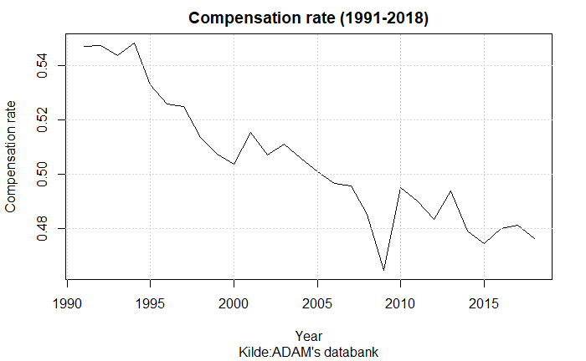

One of the major contributions to the falling compensation rate is the political regulations towards the determination of the maximum level of income insurance. In 1995 the Danish ministry of finance legislated a yearly regulation of unemployment benefits (Nørgaard, 1995)The regulation goes through the rate regulation percent which is set to equal 2% each year added by the rate adjustment percent. The rate adjustment percent is each year set according to the adjustment percent which is calculated as the change in wages two years prior to the financial year subtracted by two percent points. If the adjustment percent is lower than 0%, the rate adjustment percent is equal to the adjustment percent. Is the adjustment percent between 0% and 0.3% the rate adjustment percent is 0%. Lastly, is the adjustment percent larger than 0.3% the rate adjustment percent is equal to the adjustment percent subtracted by 0.3 percent points. This creates a situation in which wage growth of more than 2% would result in the maximum level of income insurance not following the wage growth, making the compensation rate decline over time. The plot below gives an idea of how often the wage has increased by more than two percent.

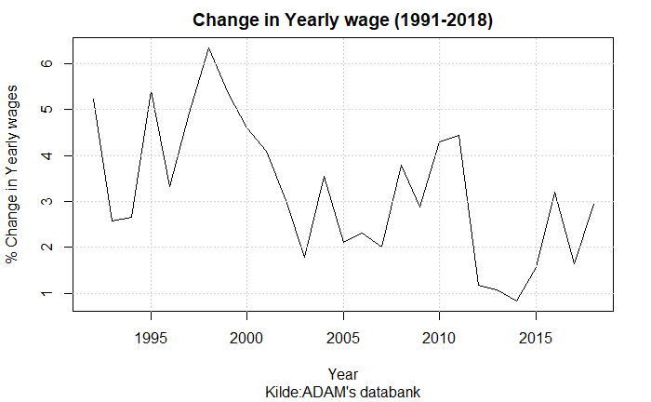

A more recent regulation is the political decision following the Danish tax reform in 2012, to suppress the regulations of employment benefits in the period of 2016-2023. As stated above the rate regulation percent is set to 2% each year. But starting from 2016, there has been a deduction of 0.3 percent points (2016), in the next year 0.4 percent points (2017) and in the period 2018-2023 the deduction was set to 0.75 percent points. (Venstre et al., 2012)

Other studies discuss whether a third reason for a falling compensation rate should be included. When calculating the compensation rate the amount paid to labor market pensions from both the worker and employer is subtracted from the wage. Therefor a larger share of the wage paid to labor market pensions will result in a higher rate of decrease in the compensation rate. One of the argumentations for including the development in the share of the wage paid to labor market pensions is that employed will benefit from their pensions later in their lives.   
This third effect is not included in the graph showing the compensation over time but including this effect should up the rate of decrease and thereby make the fall in the compensation rate even larger over time. The worker insurance started in the 1960s paying 0.9% of the wage, but over time this percentage has increased hitting 12% in 2010, where it has mostly stayed fixed. (Finansministeriet, 2017)

Despite the three main effects described above lowering the compensation rate over time, other political decisions have been made towards the income insurance program over the later years. In 2010 a new income Insurance reform was adopted, decreasing the period in which an unemployed could receive income insurance from 4 years till 2 years, as well as increasing the requirements for receiving income insurance (Dagpengekommissionens sekretariat, 2015). Later, to make the cutoff date less strict updates to the period in which a person could receive insurance were redone making it a smoother transition from the 4-year period to instead 2 years. A more recent decision is made in 2022 making two important adjustments to the IS-program. First, increasing the amount one can get in the first 3 months for people with a strong working history. Second, lowering the amount one can get going directly from education to unemployment (De Økonomiske Råd, 2022). Even though these political decisions are important for the income insurance program, the effects of these reforms will not be included in this the analysis.

Instead, this paper attempts to analyze the relationship between the macro and micro- economic effects, thereby obtaining the tools to validate the initiative from the tax-reform presented in 2012 of suppressing the rate regulation rate looking at the welfare in the Danish economy. We use a stock-flow consistent model as this first of all enables us to isolate the effect of the suppressing of the rate regulation rate, thereby not letting the just mentioned reforms affect the results. Second, it enables us to include the effects of changes in stocks, as well as including the feedback effects of changing the level of income insurance which should be of great interest when assessing the effects over time. Former studies trying to analyze the relationship between the micro and macro elasticity of income insurance on unemployment, have used boarder-based approaches, this has led to mixed results possibly duo to biased estimates based on violations of the assumptions required for these methods. A Stock-Flow consistent model will overcome these biases, and by comparing the results with a micro founded model in the form of the income insurance model build in 2015, we get an idea of the relationship between the micro and macro elasticity of income insurance on unemployment, making it possible to discuss the changes in economic welfare by completing the political initiative made in 2012. Duo to data availability and that the initiative is active from 2016, we will focus on the period of 2005-2020.

This paper makes three important contributions. First, we develop an empirical SFC-model integrating the dynamics of the Danish labor market, specifically including the variables that are used for political regulation of the unemployment benefits. Second, we do a counterfactual analysis looking at the change in welfare of the regulations made towards the unemployment benefits in the tax reform of 2012. Third, this paper contributes to the more recent focus on the aggregate effects of changes in the income insurance rate, looking at the relationship between the micro and macro effects of changes in income insurance.

The paper is organized as follows: Section 1 presented a short introduction of the political initiatives towards the income insurance program in Denmark, and its development over time. Section 2 will present the current literature on the effects of changes to the income insurance program, focusing on the micro-effects. Section 3 will take a closer look at the income insurance model build in 2015 and its strengths and weaknesses, also including the neglected macro effects in the model that newer literature finds. In section 4 we will present a quarterly SFC-model for Denmark, specifically looking at the Danish labor market. In section 5 we present results of including different macroeconomic channels in the model. In section 6 we use the results from section 5 to obtain a relationship between the macro and micro elasticity of income insurance on unemployment and use these to discuss the welfare effects of completing the initiative from the tax reform of 2012. Lastly in section 7 we conclude the results.

# Section 2: Lit review

In the later years there has been a large amount of literature towards the effects of unemployment benefits. Mostly focusing on the link between the compensation rate and employment. A large part of the literature investigating the incentive to work and job-search, has been reviewed by (Andersen et al., 2015) they find that the majority of the literature show evidence for a higher movement from unemployment to employment when reducing the unemployment benefits, thereby increasing the exit-rate from unemployment. The two main effects associated with the exit-rate are the Moral Hazard and Liquidity effect, both build on a micro foundation. (Chetty, 2008) finds that the liquidity effects explain 60% of the effect on the unemployment period when changing the level of income insurance. In contrast (Howell & Azizoglu, 2011) provide another micro founded link between unemployment benefits and work incentives as they find a positive relationship between working and happiness, independently of income insurance, thereby questioning the often-argued positive relationship between working and disutility.

(Andersen et al., 2015) also address the approach effect again building on a micro foundation it shows that a relationship should exist between the movement from employment to unemployment and the level of income insurance, they add that at the given time the literature towards the approach rate is still sparse, not showing any significant movement when changing the level of income insurance or the period of the program. Besides the effects presented by (Andersen et al., 2015), one new study is presented by (De Økonomiske Råd, 2022). This study by (Gutierrez, 2016) is looking at the change in job-search for people already in employment, they show significant evidence for a lower job-search when income insurance increases.

One reason for the lack of new literature towards the approach rate is given by (De Økonomiske Råd, 2022) who points out that newer literature is moving away from the narrow micro founded point of view of only looking at the effects on the behavior of unemployed and employed, which empirically would only result in the micro elasticity of income insurance on unemployment. Instead the newer literature focuses on aggregated effects of changes in the unemployment benefits, and thereby estimate a macro elasticity for income insurance on unemployment. (Fredriksson & Söderström, 2020) looks at the aggregated effects of a reform in Sweden concluding that the number of unemployed increases by 3% when increasing the income insurance ceiling by 1%. They find that this macro elasticity is twice as large as the elasticity coming from the micro founded effects of changing behavior of unemployed. On the other hand, a study by (Boone et al., 2021) finds that the aggregated effects are a lot lower, but still points out the importance in finding the relationship between the micro and macro elasticity. The empirical evidence at this point therefore seems inconclusive about how taking into account macroeconomic effects should affect the political decisions towards unemployment benefits.

The very popular micro founded models makes it hard to analyze these macroeconomic effects, as the models are usually build using aggregated micro effects as the total macroeconomic effect. Also, these models imply a large focus on the supply side of the economy, thereby tending to ignore the effects of the demand site. Post-Keynesian theory seems to overcome these short comings making it more suitable for this type of analysis, by not building on the narrow micro founded effects. Post-Keynesian literature determines the employment and real wages by looking at effective demand, this implies that an increase in the aggregate demand will raise the level of economic activity, creating more jobs. (Dray & Thirlwall, 2011) recall, ‘it makes little economic sense to think of growth as supply constrained if, within limits, demand can create its own supply’. This explains why we shall focus on the income distribution determinants of aggregate demand, paying less attention to the supply-side factors.

Looking at the unemployment benefits post-Keynesian theory suggests that through the demand channel a higher level of income insurance should lower the unemployment. Regarding the supply of labor, it has been argued that the decision to work along with conventional variables – such as wage rates – also depends on several factors, including norms, wages relative to other workers, consumption levels, and the standard of living. This implies that an increase in unemployment benefits may not force people to leave their jobs or stay unemployed for longer periods. (Byrialsen & Raza, 2018)

In general, post-Keynesians have proposed redistributive policies, favoring an increase in social expenditures – including unemployment benefits – which are important for income distribution. Post-Keynesians take in regard both fairness, in the form of lower inequality, and the economic gain from favoring income distribution, the last depending on whether the policy is considered to be pro-labor or pro-capital. As described by (Stockhammer & Lavoie, 2013) pro-labor distributional policies are those increasing the wage-share. Pro-capital distributional policies usually claim to promote ‘labour market flexibility’ or wage flexibility, rather than increasing capital income. Increases in the unemployment benefit is therefore seen as a pro-labor policy, if this expands the economy this is called a wage-led regime, on the other hand if this contracts the economy it indicates a profit-led regime.

Now switching towards the case of Denmark, the focus on income insurance was very high leading to the Danish election in 2015. The large debate led to a commission set down by the Danish Ministry of employment (IS-commission). The goal was to analyze changes to the income insurance program in Denmark, which in 2015 led to the income insurance model, the dynamics of this model was built on the micro effects presented above estimating the change in the exit-rate and approach-rate as a result of changes in the level of income insurance, the results of this model favored the lower level of income insurance when looking at the government net lending and unemployment. The response from worker unions and unemployment insurance companies in Denmark towards this result was first of all that the estimates of the micro effects were not correctly estimated. But most importantly they argued that the important macroeconomic effects were missing in the model.

(Jensen, 2021) argues that the behavioral effects (explained above) used to estimating the costs of an increase in the level of income insurance is miss leading. Especially they argue that the IS-commission is overstating the approach effects, stating that increasing the income insurance increases the approach towards unemployment for those employed. (Dagpengekommissionen, 2015) also themselves states that there is very low empirical evidence for this effect even existing.  
(Fagbevægelsens Hovedorganisation, 2021) add to the discussion that they don’t see the income insurance at a level where it should be pulling employed into unemployment, they argue that a large percentage of the group experiencing the highest level of compensation rate are still in job.

More recently (De Økonomiske Råd, 2022) concludes that based on new literature the estimate of the approach effect given by the IS-commission when looking at changes in the level of income insurance is overstating the negative effect that the approach effect has on employment. They split up the analysis into three scenarios one being a change in the level of income insurance. They claim that the reason for the miss leading effect might be that the commission is only including one of four effects that should be playing into the approach effect when changing the level of income insurance.

The effect included by the commission, is that people in terminated positions will experience a higher exit rate when lowering the level of income insurance, thereby more people will go into employment before joining the income insurance program. The three other effects that (De Økonomiske Råd, 2022) argues should be added into the model are the following:

First, (De Økonomiske Råd, 2022) claim that the commission is neglecting the possible effect of changes in the level of income insurance on job separation meaning a change in the number of terminations or redundancies. As the higher level of income insurance will lower the costs for a worker losing his or her job. This could lead to a lower effort put in by the worker, increasing the change of the worker getting fired. Also, the fact that a higher level of income insurance could be a chance for the worker to reorganize his or hers working life, increasing the rate in which people go into the income insurance program. (Hopenhayn & Nicolini, 2009; Hopenhayn & Wang, 1996)

Second, the change in level of income insurance could also have an effect on the job creation rate by reducing the number of advertised vacancies, this effect can be caused by higher costs for the firms both because they may have to advertise more if the job search is lower duo to an increase in the level of income insurance, or because of higher wages, as the level of income insurance plays in to the wage negotiations which will be discussed in section 3.

Third, they argue that the income insurance model doesn’t allow the change in behavior of the employed and unemployed to affect other people’s situation. The model is only looking at the individuals expected reaction to changes in the income insurance program. As will be seen in the next section, newer literature will be presented having a larger focus of the aggregate effects of changes in the income insurance program. Before presenting this newer literature, we will give a more detailed description of the income insurance model build by the IS-commission, as the result of this model gives an idea of the micro elasticity of income insurance on unemployment for Denmark.

# Section 3

The previous section gave an introduction to the literature towards income insurance, both in general and for the case of Denmark. An important observation was that the literature has moved more towards estimating the full macroeconomic effects moving away from the models built using an aggregated micro foundation like the income insurance model build by the IS-commission. In Denmark this resulted in the model facing critic for overstating the negative effects of income insurance, as well as neglecting macroeconomic effects. In this section we will present the macroeconomic effects that the newer literature is finding, but first we will give a short description of the dynamics of the income insurance model.

## The Income insurance model

The model of income insurance was developed to analyze effects of political changes in the income insurance program for Denmark, it consist of four different parts: A static model for income insurance, a static model for Cash-benefits, a Markovmodel and lastly, a re-earning model. Only the first three parts will be presented now, as the re-earning model only concern changes towards rules for re-earning the right to income insurance, thereby not looking at the level of income insurance.

The static model of income insurance is developed to calculate the immediate economic effects for a specific person being unemployed when changing the level of income insurance. For this reason, this model will not include the behavioral changes that might happen, when creating changes in the income insurance program. Similarly, the effect on cash-benefits is calculated using the static model for cash-benefits, to see if people would want to switch towards this program instead of the income insurance program.

The more interesting part is the Markovmodel which is built to calculate the equilibrium levels of employment and unemployment, to do so the population is divided into three groups: Receivers of income insurance, employed, and receivers of other social benefits. The Markovmodel estimates the probability of changing in-between the three groups, thereby looking at changes in the exit rate and approach rate, the first Indicating that a change in the level of income insurance changes the departure from unemployment to employment in the period up until the reduction and in the period immediately after. This effect is mostly concerned the unemployed with the best job opportunities to get off income insurance. The model is estimated using the 2010 reform mentioned in the introduction which shows an effect up till 78 weeks before the reduction in income insurance till 26 weeks after, this can be seen from the effect staircase shown (Dagpengekommissionens sekretariat, 2015)

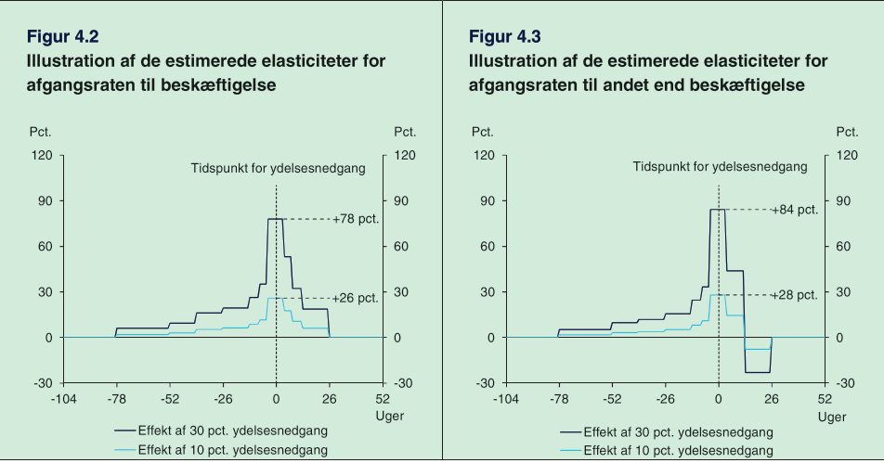

The behavioral effects are specified as elasticities meaning that a relative change in the exit rate from unemployment to employment is a function of the relative change in the gross compensation rate. Thereby the effects of an increase in the compensation rate of 30 and 10% will following their estimates have the effects of increasing the exit rate by 78% and 26%, at the time of change.

Besides the effect of the exit rate, the IS-commission also includes the approach rate, as mentioned in section 2 the commission only includes one of four effects on the approach rate argued by (De Økonomiske Råd, 2022). The commission looks at if people on their way into the income insurance program will find employment before entering the program. One issue is that data can’t show how many people are on their way to enter the income insurance program or how large their exit rates to employment is.

Therefor the commission must assume that the behavioral effects for people being close to going into the insurance program (fx from terminated positions) are comparable to the behavioral effects of people already being in the income insurance program and thereby have been in unemployment for up till 2 years.

The commission use this assumption to create a baseline for the exit rate to employment, for employed in terminated positions. Three additional assumptions visualized by (DØRS, 2022, p 257) are made to construct the exit rates for this group:

1. They assume the exit rate is 0% 26 weeks before entering the income insurance program (as there are 6 months of termination period)
2. The exit rate is assumed to be linear going from 26 weeks before joining the program till the first week of joining the program
3. The exit rate is the same just before joining the insurance program as right after. Meaning the green and red line should meet at week 0

(De Økonomiske Råd, 2022) Argues that there are missing empirical evidence for all three assumptions, they claim that people on income insurance might have more time for job searching than people being in terminated positions. On the other hand, they expect people being close to joining the income insurance program to increase their job search to avoid the fall in income.

As seen in (DØRS, 2022 p 257) the estimated behavioral effects from a 10% decrease in the level of income insurance indicates a 26% increase in the exit rate in the start of the unemployment period. This effect is included in figure B by increasing the exit rate by the values estimated from the effect staircase. Meaning a 26% increase in the exit rate in week 0.

From figure B we can now see the effect of an increase in the exit rate for people in terminated positions by looking at the change in the red line showing the change in the exit rate prior to joining the income insurance program. Therefor less will join the income insurance program, when decreasing the level of income insurance. As significant effects are found up till 78 weeks before the change in the level of income insurance for the exit rate, changes in the level of income insurance in the first 78 weeks of the income insurance program will influence the approach rate. (With lower effects the later the increase appears)

Most of the empirical evidence used for the income insurance model comes from the literature review made by (Andersen et al., 2015) This review was made specifically for the income insurance commission, and therefore influenced the effects used in the income insurance model. (Andersen et al., 2015) specifically looks at the evidence for the exit-rate and approach rate when raising the level of income insurance. They present 28 different older and newer studies looking at the exit rate from the income insurance program to employment. Looking at an increase in the level of income insurance, they find that 24 of these studies conclude a significant negative effect of the exit rate, the last 4 studies conclude non-significant negative effects, justifying the use of the exit rate in the model.

In section 2 it was made clear that the approach effect did not have the same empirical justification as the exit-rate, (Andersen et al., 2015) presents three studies looking at the approach effect when changing the level of income insurance, the two newest studies (Falch, 2015) and (Jurajda, 2002) finds no significant effects. They find that the only study showing significant effects is an older study by (Topel, 1983) based on American retrospective data from 1975. This lack of empirical evidence leads to the large number of critics presented in section 2 towards the approach rate. Newer evidence presented by (De Økonomiske Råd, 2022) show evidence for the approach rate, but finds the effect to be half the size of what is presented in the income insurance model.

We now shortly described the dynamics of the income insurance model, commenting on the validation of the effects used in the form of the exit-rate and approach rate, based on both the literature available at the time the model was built, as well as newer literature. As noted in section 2 newer literature are moving more towards including aggregated effects of income insurance, which allows us to estimate the macro elasticity of income insurance on unemployment, therefor we will now present some of these aggregated effects.

## Macroeconomic effects

(Andersen et al., 2015) points out that the majority of the literature has been based on changes in the behavior of unemployed thereby not taking into account that the change in behavior could also affect the situation for other actors in the labor market. At the time of writing (Andersen et al., 2015) mentions that there isn’t much literature looking at these aggregated effects for changes in income insurance. But one effect which should be considered is the wage-effect which explains how a change in the level of income insurance will affect the wage negotiations, expecting that a higher level of income insurance would increase the targeted wages demanded of the worker unions, to maintain a high incentive to work. The result of a higher wage is mostly based on micro level explanations in which the wage will have a negative effect in the form of lowering the demand for labor increasing the number of unemployed. The channel in which the wage affects the unemployment is different in another study by (Byrialsen & Raza, 2018) arguing that wages will affect the wage-share of the economy and depending on if the economy is wage-led or profit-led as discussed in (Stockhammer & Lavoie, 2013) the unemployment will be positively or negatively affected. They use the framework of a theoretical stock-flow consistent model, including the compensation rate in the wage equation, together with the rate of employment, and productivity. The inclusion of the compensation rate in a stock-flow-consistent framework is an addition to the model used by (Lavoie & Godley, 2012). (Byrialsen & Raza, 2018) argues that incorporating the compensation rate is in line with standard models of wage setting, which plays an important role in the determination of the targeted wage (Mcdonald & Solow, 1981; Shapiro & Stiglitz, 1984).

(Danmarks Statistik, 2012) also includes a link between the compensation rate and the wages, the link goes through the structural unemployment, which is positively affected by the compensation rate, meaning an increase in the compensation rate increases the structural unemployment. In the wage equation the difference between the unemployment and structural unemployment is affecting the wages in the next period negatively. This creates a situation where employment above the structural employment worsens the wage negotiations for workers and thereby negatively affects the wages.

The second macroeconomic effect we will present is coming of the discussion in which effects determine the exit-rate used in the income insurance model. The two main theories explaining the exit-rate are the Moral Hazard effect, and liquidity constraints. The most commonly used explanation is the Moral Hazard effect, where an increase in the level of income insurance will result in lower incentive to search for a new job, and in addition to this also be pickier regarding job offers increasing the unemployment period.

(Chetty, 2008) presents the other alternative explanation to why an increase in the level of income insurance increases the period in which people are unemployed, lowering the exit-rate. He claims that unemployed are experiencing a budget constraint, as they are using their savings to keep a higher level of consumption. When one’s savings are running low (which will take longer the higher the level of income insurance), that person might be more likely to accept jobs that are not socially efficient. If the liquidity effect is present this could lead to a matching effect, thereby leading to a worse job match between employer and employed, not taking advantage of the higher productivity the employer could have had in another job position with a better match. (Chetty, 2008) finds that the liquidity effect explains 60% of the effect on the unemployment period from an increase in the level of income insurance. Using this argumentation, we should expect a rise in the level of income insurance to have an aggregated effect on productivity. (Andersen et al., 2015) looks at the empirical evidence found for the effect of liquidity constraints on the quality of a job-match. The effect can arise through heterogeneity for both companies and workers that matters for a job-match. It will take time and costs for both companies and workers to localize a good match. In Addition to this there will be a lock-in effect as there are associated costs of firing/quitting and finding a new employer/employed. This means that workers might not be in the job where they are maximizing their productivity, and reallocation of the working force could therefore lead to a higher output.

Therefor when increasing the level of income insurance, there will be a decrease in job search lowering the employment quantitively, but the quality might increase duo to the above-mentioned effect. (Andersen et al., 2015) presents two measures for the quality of the working force, the wage and hiring period. The challenging part being to control for other effects, affecting the wage and hiring period.

(Andersen et al., 2015) presents several studies, all indicating that a more generous income insurance program results in extended unemployment period, approximately half of the studies finds positive effects on the match-quality, the other half finds no effects, and one study find significant negative effects. The majority of the studies only find evidence using changes in the income insurance period, and not the level of income insurance.

A possible explanation for the weak empirical evidence is also presented by (Andersen et al., 2015) who shows evidence for a reverse effect of income insurance on the productivity, they argue that as people are spending longer time unemployed, their human capital falls, lowering their productivity. This may be capable of explaining the mixed empirical evidence for a channel existing between the level of income insurance and productivity.

A third channel affecting the economy is going through the demand created when raising the income insurance. The demand channel suggests that changes in level of income insurance affect the level of aggregated demand and thereby the demand for employment. (Byrialsen & Raza, 2018) include this channel when analyzing the macroeconomic effects of income insurance.

Another channel not getting that much attention in the literature, is the effect of income insurance on the participation rate, in the income insurance model this channel is partly accounted for. As the income insurance model use the static model for cash-benefits to estimate the alternative for income insurance. If the cash-benefits are relatively close to the income insurance the incentives for a person to keep applying for jobs and thereby staying in the labor force is quite small. The relationship between income insurance and the cash-benefits should therefor affect the participation rate, also accounted for in the income insurance model.

(Fazzari et al., 2020) argue for an additional effect going into the participation rate, as he endogenizes the labor force using the strength of the economy measured by the unemployment rate as a regressor. He argues that the unemployment rate should have a negative relationship with the labor force, one reason is a decline in labor force participation due to the rising difficulty of finding an acceptable job match as unemployment rises, also higher unemployment tends to reduce immigration as found in (Setterfield, 2003).

Lastly, as the income insurance program is not mandatory in Denmark, it is argued by (Aastrup, 2018; Fagbevægelsens Hovedorganisation, 2021; Jensen, 2021) that one should expect a lower compensation rate to affect the insurance rate (The rate of workers being a member of the income insurance program) They find that in the same period as the fall in the compensation rate, the percentage of the working force being a member has dropped from 84% till 78% even though this period has included political adjustment intended to raise this percentage (Fagbevægelsens Hovedorganisation, 2021). Assuming it will be the people with the lowest chance of losing their job leaving the insurance program this would lead to lower membership payments therefor requiring larger financing from the government. In addition (Økonomiske Råd. Formandskabet, 2014) argues that this in the long run will lead to higher requirements towards termination notices and thereby undermine the Danish flexicurity model.

We are now one step closer to being able to assess the political decision of suppressing the rate regulation percent. Taking into account the large amount of critics of the income insurance model we should be able to use this model to estimate the micro elasticity of income insurance on unemployment. And now after presenting several macroeconomic possible channels for the income insurance model we want to estimate the macroeconomic elasticity of income insurance. For this we use a stock-flow consistent model for the Danish economy presented in the next section.

# Section 4: Model description

In this section we will present the model built to analyze the macroeconomic effects that the literature finds but are neglected by the income insurance model just described. We do this by introducing channels that include the effects described in the previous section using the results to assess the political decision to suppress the rate regulation percentage starting from 2016. To do so, we utilize the features of a stock-flow consistent framework building upon the existing empirical stock flow consistent model for Denmark developed by (Byrialsen et al., 2022). This section will present the fundamental equations included by (Byrialsen et al., 2022), whereafter we focus on the central equations added to include the new dynamics. First, creating a baseline model where only the demand channel is analyzed, after validating the baseline model the wage, labor force, productivity and insurance rate channels are added to the model to analyze the economic effects of each channel. Lastly, we look at a scenario where all the five channels are included. In all the scenarios we look at the effect of removing the suppressing of the rate regulation percent.

## Fundamental equations in baseline model

Before presenting the central equations for incorporating the Danish income insurance program in the model, we start by introducing some general equations being important for the results of this paper. The equations follow the work of (Byrialsen et al., 2022), but some with small adjustments to incorporate the income insurance program.

One of the central aspects of this paper is to find the effect of income insurance on unemployment, with unemployment being determined of the difference between the amount of people employed and the labor force:

As the labor force is exogenous, the unemployment is highly dependent on the demand for employment. As mentioned in section 2, the post-Keynesian theory is mostly demand driven, therefor the firms will hire workers to meet a certain demand. Therefor the employment is determined by total production in real terms and the productivity of workers.

Here we assume that total production takes place in the non-financial corporations and is determined by the aggregate demand. The total production in real terms is determined in the standard way as follows:

For this paper the main effects of income insurance will go through the household’s disposable income and into the consumption of the households (). The income insurance will go through the net benefits of the households () as this is split into two components () and () the later one determining the total amount received by households in income insurance, and the first determining all other benefits but income insurance received by households. This then feeds into the disposable income for households through the component of current transfers ().

For the household’s consumption we find cointegration between the real consumption and both real disposable income and real financial wealth. Therefor the consumption function is estimated using an error correction model, taking the following form:

In appendix we have included a DAG presenting the overall flow of the model but for now, we will opt into presenting the central equations for incorporating the income insurance program into the model.

One of the most central components, is the inclusion of the maximum level of income insurance (). Once every year the ministry of finance will set the maximum level of income insurance as of why the variable will only change in the 1. Quarter and stay fixed for the rest of the year. In the baseline model follows the political regulations stated in the introduction, where it follows that the maximum level of income insurance grows by the state regulation percentage () plus the rate adjustment percentage () each year.

As the Ministry of Finance determines the state regulation percentage it is held exogenous in the model. On the other hand, the rate adjustment percentage is calculated each year, using the adaption percentage, following the rules stated earlier in the introduction we need to set up three conditions: First, if the adaption percentage is lower than 0 the rate adjustment percentage is equal to the adaption percentage. Second, if the adaption percentage is between 0.0 - 0.3% the rate adjustment percentage is set to 0. Third, if the adaption percentage is above 0.3% the rate adjustment percentage is equal to the adaption percentage minus 0.3% points.   
As with , the rate adjustment percentage is calculated in the 1. Quarter and held fixed to the end of the year.

The adaption percentage is calculated by taking the wage growth two years before the financial year subtracted by 2% point, it should be noted that we use the yearly wage growth, which in the model is calculated using the 1. Quarter, therefor the adaption percentage is only calculated for 1. Quarter and held constant for the rest of the year.

The endogenization of is now completed within the model, which now allows us to calculate the compensation rate within the model. The compensation rate is estimated as the fraction of the average amount an unemployed on income insurance would receive (), to the average wage received by workers ().

To calculate we use a simple OLS regression linking the maximum level of income insurance to the average benefits received by unemployed eligible for income insurance. This is done as an alternative of using aggregated data of benefits received by households, as the gap between observed unemployment and estimated unemployment in the model at some points are quite large, thereby creating a lower average of benefits received. Looking at data from ADAM’s databank we know that approximately 85% receives the maximum level of income insurance meaning that the increase for the people not getting the maximum level would be less. For this reason, we know that the coefficient should be between 0.85 and 1, and most likely closest to 1 as most changes in the income insurance are coming from the change in wage which also affect the level for people not receiving the maximum level. This is also observed as the coefficient estimated is 0.9507 observed below.

The average level of income insurance is then transformed into an aggregate variable, multiplying it by the number of unemployed and the insurance rate giving the total amount paid in income insurance to the households .

The total amount paid in income insurance to the households then feeds into the households’ disposable income, this summarizes the demand channel created in the model for changes to the income insurance program, it should be noted that this effect is not accounted for in the income insurance model.

The total amount of income insurance also feeds into the net lending’s of the government, here it is assumed that the government finances the entire IS-program, which is not the case in reality, the effect of a change in the level of income insurance will therefor overshoot the effect on government net lending.

Another key variable in the labor market is the participation rate, showing the ratio of the population being in the labor force. In the baseline model we keep this variable as exogenous. A main reason for having the participation rate exogenous in the baseline model is that within the dynamics of the Danish labor market, many have failed to determine what brings people into the labor force, in section 2 the literature argued that participation could follow several factors, including norms, wages relative to other workers, consumption levels, and the standard of living. In Scenario 4 we look at a scenario in which the participation rate is made endogenous using the method from (Fazzari et al., 2020) as we find a significant relationship between the unemployment rate and the labor force.

## Validation of the model

In this section we look at the performance of the model, comparing the results from the simulation of the baseline model with actual data, we keep a specific focus on the variables in the labor market.

In the figure below we compare the simulated and actual data for GDP, Employment, maximum level of income insurance and the compensation rate.

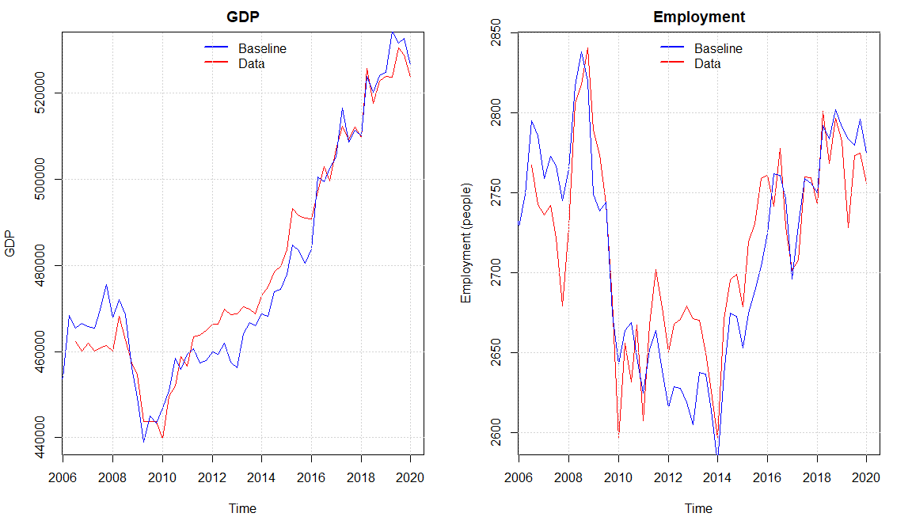

We observe that the model seems to capture the same dynamics of the real economy as (Byrialsen et al., 2022) with a small overshooting in the economic activity in the period 2011 - 2016 explained by a higher simulated value of real investment and consumption compared with the data. Overall, the model seems to capture the medium to long-run tendency of the data even though there are some divergences in some quarters. The Overshooting in the activity also results in a higher level of the maximum level of income insurance in some periods when looking at the baseline model. As the increase in wage growth goes directly into the compensation rate in the same period, meanwhile the maximum level of income insurance will be affected with a lag of 2 years, we observe that the compensation rate is a bit higher in the baseline compared with real data around 2010 - 2012, but as the adjustments to the income insurance through higher wages happens it goes back to follow the real data.

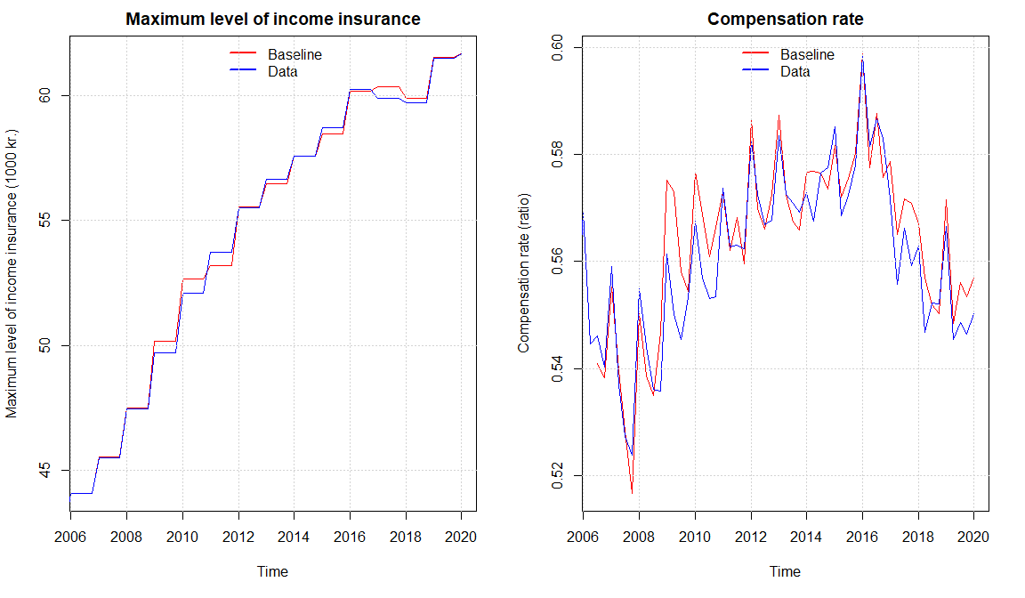

We can see that the compensation rate is slightly increasing, especially from around 2008-2016, one of the reasons is an ongoing slowdown in the growth rate of the wages. Comparing with the results of (Økonomiske Råd. Formandskabet, 2014) the development fits very well, they as well use a macro-based calculation of the compensation rate. Most importantly we see a fall in the compensation rate in the years of suppressing the regulation of the maximum level of income insurance from 2016. Which was also expected looking at the forecasts made by (Økonomiske Råd. Formandskabet, 2014).

Overall, we see that the data for the labor market is well replicated by the model, creating a basis for analyzing the neglected macroeconomic effects to thereby obtain an estimate of the macro elasticity of the level of income insurance on unemployment, making it possible to analyze the suppressing at the rate regulation rate.

We already introduced a demand channel for the IS-program in the baseline model, therefor when we start to analyze different channels independently it should be noted that the demand channel is still active. In scenario 1 we will introduce the counter factual shock of removing the suppressing of the income insurance to get an estimate of the effect this channel has on the economy and especially unemployment. Next, we start by including more channels for the income insurance to affect the economy. In scenario 2 we introduce the effect of the maximum level of income insurance on the targeted wage, and how this affects the wage negotiating process. In scenario 3 we include the link between the compensation rate and the rate in which people want to be a member of the income insurance programs. In scenario 4 we include an indirect effect of income insurance, when endogenizing the labor force using the unemployment rate as a regressor. In scenario 5 we will look at the match-effect (as a result of the liquidity effect) as well as the Verdoon effect, when explaining productivity. In scenario 6 we introduce all the channels at once, so that the effects of one channel can feed into another.   
We would like to obtain the results of all the channels for the counter factual situation in which the suppressing of the rate regulation is removed, to be able to discuss this in the next section.

## Scenario 1 No suppressing of the rate regulation percent

In this first scenario we test the effects of the demand-channel included in the baseline we do so by performing a counter factual shock removing the suppressing of the rate regulation percentage introduced in the tax reform of 2012. Instead, the rate regulation percentage will be held fixed at 2% still subtracted the rate adjustment percent. As expected, this raises the average income insurance as people having the maximum level of income insurance will experience an increase in their income insurance. The increase in the average income insurance will go directly into the compensation rate. Both increase by approximately 3.5% in the period of 2016-2023, which can be seen below.

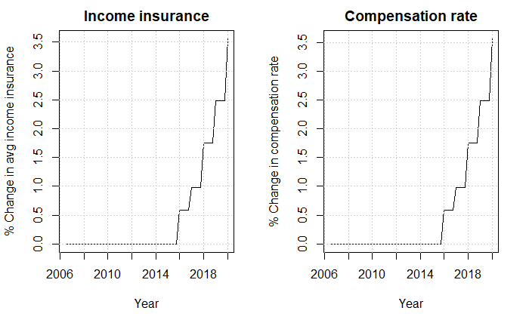

The increase in the average level of income insurance, increases the net social benefits received by the households, and thereby raises the disposable income of the households. As the increase in net social benefits for the households are financed by the government the net lending of the government will fall. These effects take into account the increased tax payments that the households will experience.

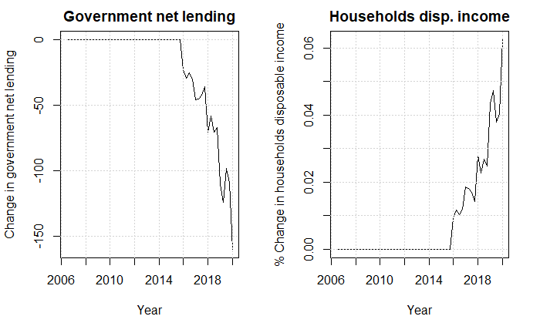

The increase in disposable income increases the consumption and therefor also the GDP. The increase in GDP will increase the firms demand for jobs and thereby raise employment.

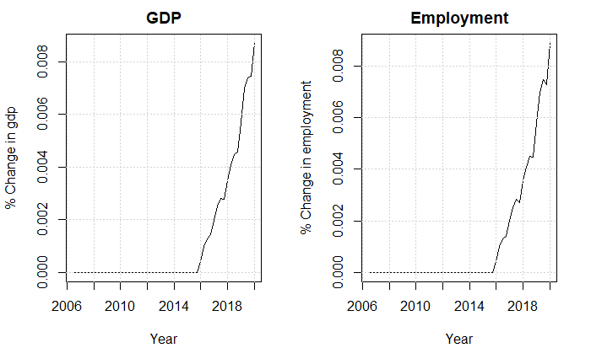

The only effect of removing the suppressing of the rate regulation percent in scenario 1 goes through the demand channel. As it is only a minor part of the population experiencing an increase in income, the macroeconomic effects are minimal but still expands the economy. Calculating the change in unemployment coming through the demand channel we get that unemployment decreases by approximately 250 people. One of the most central estimates when analyzing the demand channel is the one describing the relationship between maximum level of income insurance and the average income insurance estimated to 0.95 in the baseline. We know that the estimate should be between 0.85 and 1 but are dependent on the shock happening to the economy. The shock used in this scenario does not change the wage, which means it is only the people receiving the maximum level of income insurance experiencing an increase. If the change to the maximum level of income insurance goes through the wage instead, the estimate should be closer to 1, as people not hitting the maximum level will increase their level by 90% of the increase in wages. Therefor using the lower bound of 0.85 and an upper bound of 0.99, it seems like changes to the estimate doesn’t affect the final results much, running a sensitivity analysis shown in appendix we see a decrease of unemployment on 223 (estimate of 0.85) to 254 (Estimate of 0.99)

In scenario two we will introduce the wage channel in the model while still creating the same counterfactual scenario in removing the suppressing of the rate regulation rate.

## Scenario 2 Including income insurance in the wage negotiations

As presented in section 3 the literature agrees that the level of income insurance plays a role in the wage negotiations. In the model this effect is created through a targeted wage () which is set by the labor unions going into the wage negotiations. The labor unions got two agendas when determining the target wage. First, they want the wage to follow inflation so that workers keep their purchasing power over time. Second, they set a threshold for the minimum wage gap measuring the difference between the wages and maximum level of income insurance relative to the wages, to maintain a certain incentive to stay unemployed. In the model the minimum wage gap is set to 42% of the wage, which is giving us an elasticity of income insurance on wages. Close to the one found by (Fredriksson & Söderström, 2020). In the case where inflation is not able to close the minimm wage-gap alone (thereby leaving the gap to be below 42% of the wage), the labor unions would set the target wage so that the wage gap is exactly 42% of the wage. The equation for the target wage and the wage gap can be seen below:

The targeted wage is then included in the behavioral equation determining the wage, estimated to have a positive effect on the wage in the long run.   
Performing the same shock as in scenario 1 by removing the suppressing of the rate regulation rate, we see that the targeted wage increases by almost 4% in 2020. We see that when the workers unions go into the negotiations with a higher targeted wage, this also affects wages. As the firms are now experiencing higher costs, this will go into the consumer prices.

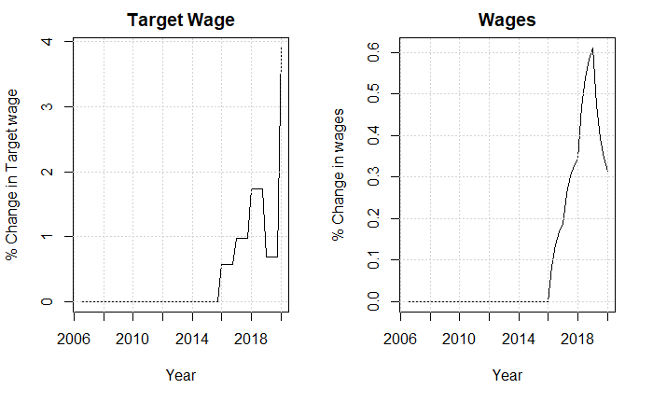

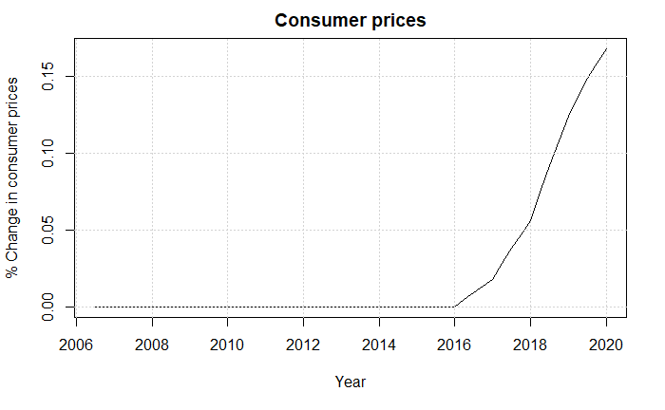

As the wages increase, so does the wage-share in the model. As argued by (Onaran & Galanis, 2012) the final effect of a rising wage-share (falling profit-share) In the end it comes down to the effect on consumption, investments, and the trade balance of the economy.

We start by looking at the consumption and investment, looking at the investments first we see that increasing the wages, leads to an increase in the wage share thereby lowering the profit share. A lower profit-share means that firms are experiencing a lower return on investments thereby decreasing the future investments. When investments start falling there will be a larger capacity that the firms can utilize. At the same time the lower investments also decrease the economic activity which decreasing the capacity of the economy. These two adverse effects are captured by the capacity utilization rate, where it seems like the first effect is dominant leading to a small increase in capacity utilization which will increase the firms’ incentives to invest, but as this effect is quite small the overall effect will be a fall in investments.

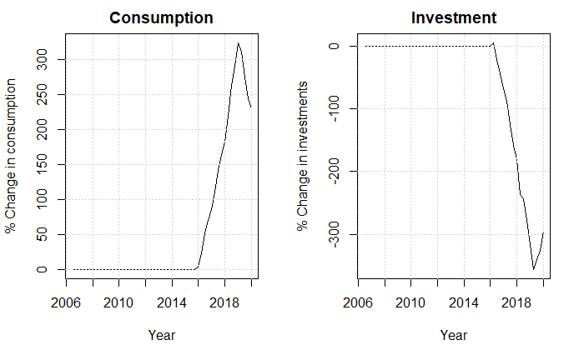

From the plot we observe an increase in consumption duo to the higher wage share, meaning that a higher share of the income is coming through the wages. As the propensity to consume is larger for wage income compared to profits, the consumption for the households will increase.

At the end we can conclude that the fall in investments is larger than the increase in consumption which is also found by (Onaran & Obst, 2015) The last part we need to analyze is the net-exports, as the increase in the wages directly goes into the price equations, consumer prices will increase, resulting in a lower net-exports observed below.

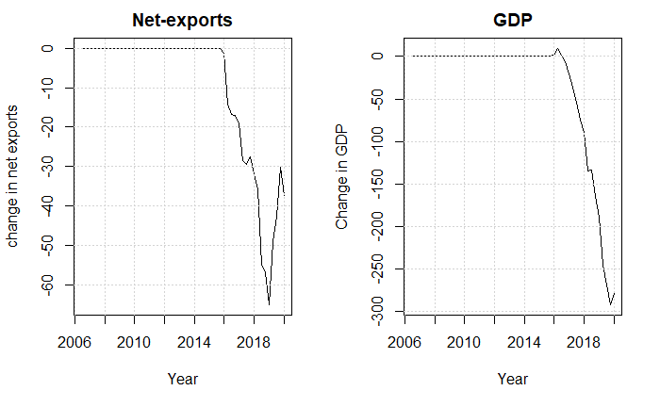

In total we see that the increase in consumption is smaller than the decrease in the net-exports and investments, lowering the economic activity. The unemployment as a result of removing the suppressing of the rate regulation rate is increases by approximately 1500 people in 2020. In the next section we will add a new channel in affecting the rate in which people want to be a member of the income insurance program.

## Scenario 3 Effect of compensation rate on the insurance rate

In the baseline model the insurance rate ( is set exogenous, but as presented in section 2 many organizations criticize the income insurance model for not including the channel in which the compensation rate should impact people’s choice in joining the insurance program. The reason is that the membership costs compared to the generosity of the program will make the members worse of when the compensation rate is lower. The central mechanism will be that the demand site of the economy will be affected positively when a higher percentage receive income insurance when unemployed. The equation added to the model can be observed below:

As noted previously the data used for the percentage of people being a member of the income insurance program is obtained from ADAMS databank, therefor we only estimate the equation till 2017 quarter 4 duo to data availability. We find a positive long-run relationship between the compensation rate and the insurance rate; the results are significant at a 10% significant-level.

As this scenario only includes the demand channel together with the insurance rate channel this will only increase the effect of the demand channel, we will compare the results of the shock with the results of scenario 1 for this reason. First, we see that the increase in compensation rate increases the incentive to join the insurance program thereby a higher percentage of the unemployed will be receiving income insurance increasing the net benefits received by the households. Using the same reasoning as in scenario 1 we can observe the effects on government net lending and disposable income.

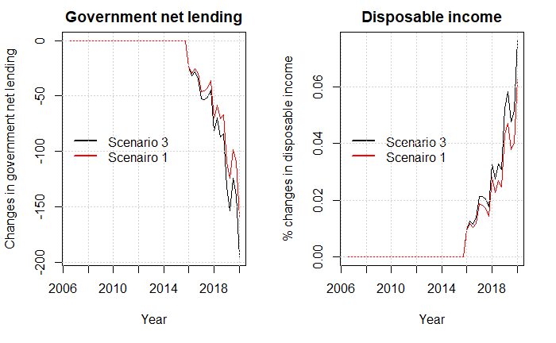

It shows that endogenizing the insurance rate, increases the demand effect that we saw in scenario 1. In the plot below we observe the effect on GDP with and without adding the insurance rate channel.

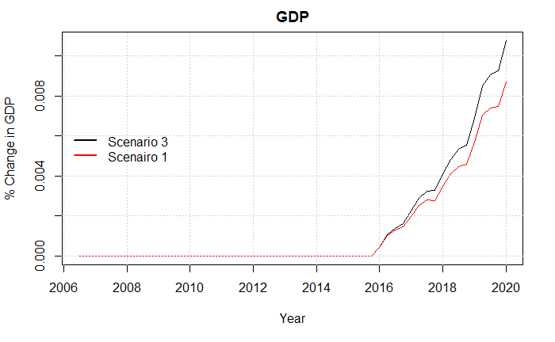

Lastly, we look at the effect on unemployment here we observe that the effect lowers the unemployment comparing with the results of scenario 1. The total effect on unemployment when including this channel is a fall of 300 people, thereby extending the fall by 50 people compared with scenario 1.

## Scenario 4 effect of maximum level of income insurance on participation

In section 3 we described the two static models build by the IS-commission including the dynamics of pulling people in and out of the labor force when looking at the relationship between the income insurance and cash-benefits. As this effect is already accounted for in the income insurance model and thereby the micro elasticity, we will not include this link, instead we will use the effects used by (Fazzari et al., 2020)

As mentioned, the participation rate in the baseline model is set exogenous as the literature is still mixed regarding what determines the participation rate. We find significant effects using the method presented by (Fazzari et al., 2020) who endogenize the labor force in the model using the unemployment rate as a regressor, here we should expect a negative relationship between the unemployment rate and the labor force. The main explanations used by (Fazzari et al., 2020) for this negative relationship is that the rising unemployment rate would indicate rising difficulties of finding acceptable job matches, which might create incentives for some people to stay outside the labor force. The new equation for the labor force can be seen below

The labor force can then be used for calculating the participation rate in the Danish economy, using the equation below:

Comparing the simulated data with the real data we see that the model is able to capture the overall trend of the data:

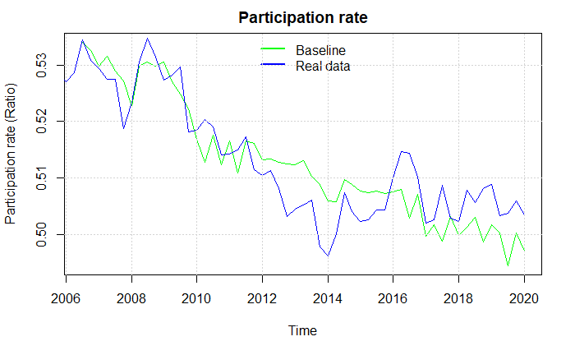

When removing the suppressing of the rate regulation rate we get almost the same results as in scenario 1. As the shock in scenario 1 had a minimum effect on the unemployment rate, the effect going into the labor force is also minimal creating almost no difference in the two scenarios. The only difference is that we see a small increase in the labor force of approximately 50 people. When estimating the unemployment, we see a fall of approximately 150 people in this scenario. In scenario 5 when introducing all effects together, this channel will play a larger role, as the unemployment rate will be more heavily affected.

## Scenario 5 New productivity effect

As argued by (Chetty, 2008) 60% of the change in the unemployment period due to changes in the level of income insurance can be attributed to the liquidity effect. This creates a possible additional channel in the form of the matching effect, where increases in the level of income insurance affects the productivity, as unemployed are more financially robust to stay longer time in unemployment searching for a better job-match. As mentioned in section 3 empirical results are only finding weak evidence for the existence of the matching effect having an effect on the productivity, mostly because of the problem in finding realistic proxy variables for the productivity. The effect is included in the model by endogenizing the productivity function, using the level of income insurance per person as a regressor, as can be observed below. Also, the Verdoon-effect described by (Millemaci & Ofria, 2014) and mentioned in section 3 will be included. We find significant results for both effects, like (Fazzari et al., 2020), who also uses the Verdoon-effect, we control for wages as an explanation for a supply site factor explaining productivity, also here we find significant results.

As the increase in the average level of income insurance now feeds directly into the productivity, we below observe an increase in productivity compared to the baseline model after 2016.

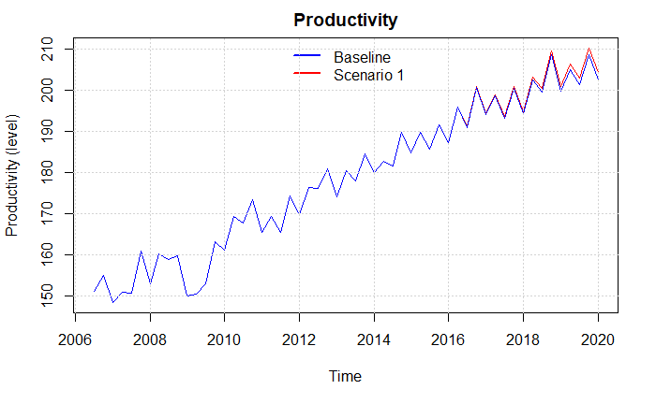

As the economy in a post-Keynesian SFC model is demand driven this goes for the labor market as well, therefor when increasing the productivity while having the same demand, firms will lower the number of workers to meet the same level of demand, therefor increasing the number of unemployed in the economy by around 25.000 which is a 15 percent increase in the number of unemployed, at the same time we see an increase in the economic activity both observed in the plot below.

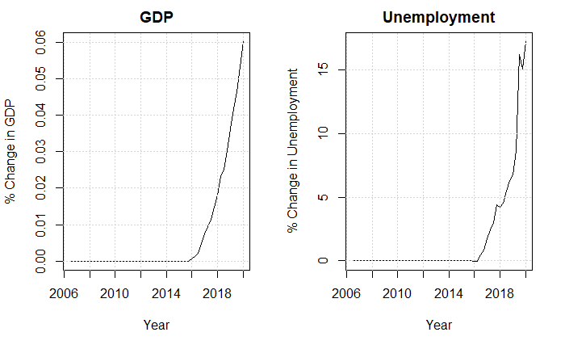

We find this effect quite large especially compared to the other effects. In the sensitivity analysis we therefor relax the assumption of firms being able to lay of workers when they become more productive. We do this by only allowing firms to lay of half of the workers they want to when trying to match the same demand when workers become more productive, the results can be seen from appendix.

## Scenario 6 All effects

In the previous scenarios we included channels one by one to analyze how they affected the economy, thereby we obtained an indication of the independent results of each channel. Now, we will introduce a scenario including all the channels in the economy at once, doing this we allow the effects of one channel to feed into other channels. We will focus on the effects on unemployment, government net-lending and GDP comparing the results with the previous scenarios. We do this for two cases, one excluding the productivity channel. The reason for not including the productivity channel is partly explained in the previous scenario where we saw that the results of including the productivity channel was quite radical, but also because the literature presented in section 3 mentions the general problem of finding good estimates of the matching effects, making it impossible to validate the effects found in the previous scenario.

We know from the independent effects that the wage channel seems to be the most dominant, as also indicated in the plot below. When including the effects together we see an increase of almost 1000 more unemployment compared to when only including the wage channel. We attribute this increase of 1000 people mostly to the LF-channel, as the wage channel increase unemployment, the increase in unemployment decreases the labor force by approximately 750 people, which results in a lower economic activity thereby lowering the employment. We see that the fall in the employment is larger than the fall in the labor force, therefor increasing unemployment further. In the end the total effect on unemployment when including all channels but productivity turns out to be an increase of 2362 people.

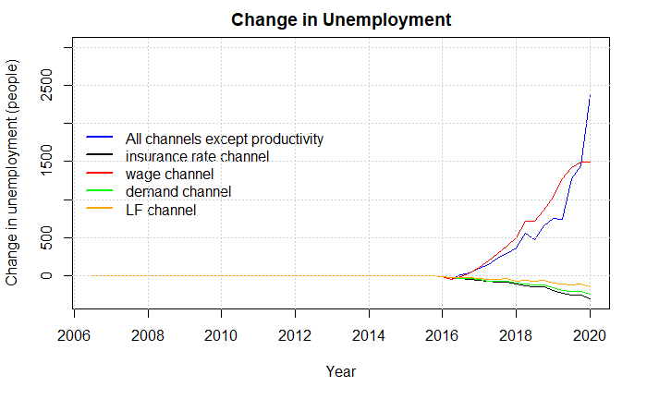

We can also look at the change in Government net-lending here we see a large increase after 2018. This is duo to the overall lower economic activity lowering the tax payments towards the government, as well as the higher amount of unemployed increasing the payments from the government towards the income insurance program.

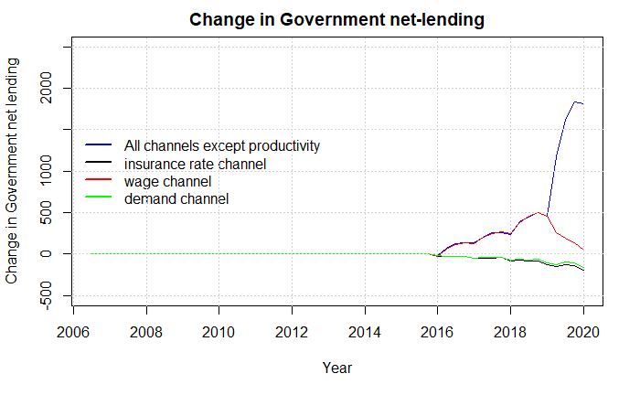

We can also compare the effects on GDP. As mentioned, we observe a lower economic activity as people start leaving the labor force duo to the higher unemployment, making the fall in GDP larger when including all channels but productivity.

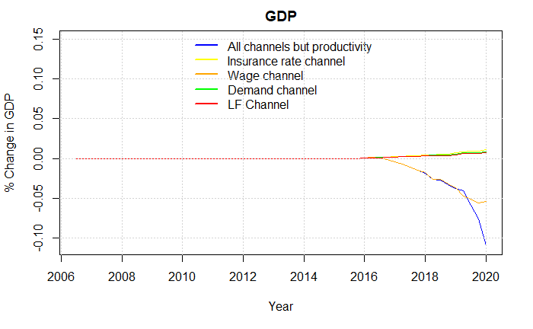

We will now use the results obtained from scenario 1-6 to get an idea of the relationship between the micro elasticity and macro elasticity of income insurance on unemployment, we will compare this with newer literature trying to estimate the same relationship in other countries, here we will especially use the study by (Fredriksson & Söderström, 2020) who finds the relation between the two elasticates for the Swedish economy.

# Section 5: Discussion

## The relation between the micro and macro elasticity for Denmark

In the previous section we introduced several macroeconomic channels that showed significant effects on the Danish economy through changes in the level of income insurance. All these effects were also introduced in section 3 as neglected effects of the income insurance model built in 2015. In total we analyzed 5 effects neglected in the income insurance model. In scenario 1, the demand channel decreasing unemployment by 223 - 254 people. In scenario 2, the wage channel adding 1500 unemployed when matching the elasticity of income insurance on the wage presented in (Fredriksson & Söderström, 2020). In section 3, the insurance rate channel reducing the number of unemployed by 300 people. In section 4, the labor force channel decreasing unemployment by 150 people. In section 5, the productivity channel adding 25000 unemployed. Finally in section 6, including all the channels beside the productivity channel increased the number of unemployed by 2362 people.

As mentioned in scenario 5, we find the results of the productivity channel quite radical, together with the fact that the literature are finding mixed results for this channel, we excluded it in scenario 6. In appendix we show the total effects of including the productivity channel together with all other scenarios, we find that unemployment increases by 23.000, for the rest of the discussion we will not comment on this result further.

When discussing a political decision like suppressing the rate regulation rate, it is radical to know the relationship between the macro elasticity and micro elasticity for the Danish economy. To our knowledge no one have compared these for the Danish economy yet, making the income insurance models results “useless” in a macroeconomic perspective. (Fredriksson & Söderström, 2020) concludes that when not knowing the macro elasticity relative to the micro elasticity of income insurance it is not possible to make the right political decisions. If the macro elasticity equals the micro elasticity, then the Baily-Chetty formula applies directly (Baily, 1978; Chetty, 2006). If the macro elasticity is greater than the micro elasticity, and there are aggregate inefficiencies, then income insurance should be set lower than the level dictated by the Baily-Chetty formula. A key question is thus whether the macro elasticity is greater/lower or equal to the micro elasticity. (Fredriksson & Söderström, 2020)

Most of the literature touching on the relationship between the macro and micro elasticity is coming from the US (Boone et al., 2021; Dieterle et al., 2021; Hagedorn et al., 2013, 2016)looking at The Great Recession which brought a series of UI benefit extensions that were in many ways unprecedented in the United States (Dieterle et al., 2021). The results of these empirical tests are mixed and not giving a clear view of the relationship between the macro and micro elasticity. One reason given for the mixed results is that all the papers use causal effects methods to estimate their results using boarder-based approaches, this puts up two conditions: First, it requires that the areas being compared on either side of the border would experience similar labor market conditions in the absence of a difference in benefit level. Second, it also requires that the effect of the policy is concentrated on one side of the border, meaning the effects on one site of the border can’t spill over to the other site. (Dieterle et al., 2021) argues that not all papers have been able to fulfill these conditions, making the results mixed.

We already introduced the study by (Fredriksson & Söderström, 2020) who use changes in the replacement rate of the wage when going to unemployment by taking advantage of the heterogeneity in high-wage and low-wage regions, here it is assumed that lowering the ceiling reduces benefit generosity more in high-wage regions, since high-wage regions also tend to be low-unemployment regions. (Fredriksson & Söderström, 2020) finds that the macro elasticity on unemployment in Sweden is twice as large as the micro elasticity with a macro elasticity of 3 compared to a micro elasticity of 1.4-1.5.

They argue that the main effect is duo to the higher wage pressure, following an increase in UI generosity. (Fredriksson & Söderström, 2020) finds empirical evidence that wages rise as a result of an increase in UI generosity. Overall, the elasticity of interest is in the order of 0.2–0.3. The macroeconomic consequences of higher wages argued by (Fredriksson & Söderström, 2020) is that firms respond by creating fewer jobs and, so, market tightness is reduced increasing unemployment – over and above the direct effect coming from reduced search incentives among unemployed workers. But they never show any evidence for this channel when looking at vacancies. Another study looking at this effect is (Marinescu, 2017) finding no effect on vacancies when looking at the effects of a more generous income insurance program.

Comparing with our results, we also conclude that the wage-channel is leading the increase in unemployment, as mentioned in scenario 2, we set the maximum gap allowed by worker unions so that it approximately match the elasticity found by (Fredriksson & Söderström, 2020) of 0.2-0.3. Instead of using the effects of higher wages explained by (Fredriksson & Söderström, 2020) we find significant evidence for the post-Keynesian explanation of wages affecting the investments, consumption, and net exports explained in scenario 2. As argued by (Onaran & Galanis, 2012) the effects goes through the wage-share if an increase in the wage-share affects the economy positively, the demand regime is called wage-led; otherwise, the regime is labeled profit-led. They also argue that small open economies (as Denmark) usually are profit-led, thereby expecting a contraction of the economy. (Onaran & Obst, 2015) estimating the results for Denmark finds that the Danish economy is profit-led, even as a closed economy. These results are also in line with the results we find in scenario 2, as the increase in consumption is lower than the decrease in investments. (Onaran & Galanis, 2012) looking at the effect of multiple developing and developed countries finds that the effect of an increase in the wage-share for all countries results in an increase of consumption that are larger than the negative effect on investments, and conclude that when looking at the G20 countries in the European union in total are found to be wage-led, which would most likely result in a totally different conclusion as the results for these countries in scenario 2 most likely would have been a decrease in unemployment, possible reversing the relationship between the macro elasticity and micro elasticity. In the appendix we perform a sensitivity analysis finding that we should see very large changes to the important estimates in the consumption, investment, export and import functions to change the conclusion of Denmark being profit-led.

To obtain the overall effect on unemployment, we use the same idea as (Lalive et al., 2015) where calculating the overall effect (the macro effect), using the sum of the micro effect and market externalities. So, if finding significant market externalities as we do in our study, we can use those together with the micro effects of the income insurance model to get an idea of the relationship between then macro and micro elasticity.

One possible critic of this method is that the effects from the income insurance model and the model built in this paper will not interact. For example, when looking at the counterfactual scenario in the macroeconomic model we should add in the increase of unemployment by approximately 3000 people as a result of the effects from the income insurance model. This probably would affect the other channels as well. We believe that this might not change the overall results, as it will have no effect on the most dominant channel being the wage channel.

The micro elasticity for Denmark is estimated using the model of the IS- commission, the ministry of employment in 2020 received a question for calculating the effects of removing the suppressing of the rate regulation rate in the period of 2021-2023. In the response it is estimated that the removing of the suppressing will result in an increase of 2.25% in the level of income insurance. In total this increase will lower employment by 2900 people, they further split the effect up to the one estimated from the exit-rate (1600 people) and the one for the approach-rate (1300 people). As mentioned by CEVEA the effect of the controversial estimate for the approach effect is approximately 45% of the total effect. (Hummelgaard, 2021)

When estimating the micro elasticity, we will therefor follow the results from (De Økonomiske Råd, 2022) who argues that the estimate for the approach effect used in the IS- model is twice as large as what newer literature suggests. We will also look towards the case in which this effect is not present at all as argued by (Aastrup, 2018; Fagbevægelsens Hovedorganisation, 2021; Jensen, 2021) also because the literature is still very sparse regarding the approach effect as a result of changes in the level of income insurance mentioned by (Andersen et al., 2015).

Using the answer given by the ministry of labor above we calculate the micro elasticity of the level of income insurance on unemployment to be 0.66, when using the argumentation from (De Økonomiske Råd, 2022) we find that the elasticity drops to 0.51, the last estimation removing the approach effect entirely we find an elasticity of 0.36.

When calculating the macro elasticity, we have the option to just add the effects of the different channels independently, this will make it easier to pinpoint which effects are contributing with how much, as argued before this will remove the interaction between the different channels. Therefor all channels will be included as in scenario 6 for calculating the macro elasticity, using the channels independently to get an idea of how much each channel contributes to the total effect. We estimate the macro elasticity to be approximately 0.35-0.4. This implies that the macro elasticity in Denmark is larger than the micro elasticity, thereby finding results comparable to the findings of (Fredriksson & Söderström, 2020).

In the next section we will use the relationship between the micro and macro elasticity of income insurance on unemployment to validate the decision to suppress the rate regulation percent starting in 2016, we do so using the Baily-Chetty function.

## Validation of the suppressing of the rate regulation rate

In the previous section we obtained an estimate of the macro elasticity and micro elasticity for Denmark, comparing these results with other studies looking at this relationship, we find a relationship very close to the one found by (Sweden) for the Swedish economy. We now pursue using this to validate the decision to carry through the suppressing of the rate regulation rate starting in 2016, using the Baily-Chetty function. The function evaluates the benefit level by using three important parameters. (1.) The elasticity of unemployment with respect to benefits (). (2.) The drop in consumption as a function of benefits ( )and (3.) a coefficient of relative risk aversion, reflecting the value of having a smooth consumption path ().

The idea of the function is to measure the marginal gains in the form of higher consumption when unemployed, to the marginal costs in the form of higher tax payments. This is done by weighting against . (Økonomiske Råd. Formandskabet, 2014) uses this formular in the case of Denmark, using the compensation rate as a proxy for the change in income. They also argue that setting the relative risk aversion is tough for Denmark, but literature seems to use 1 or values a bit above 1. Looking outside Denmark (DREAM, 2013) estimates the elasticity to be approximately 1.5 looking across different countries. (Finkelstein & Chetty, 2012) estimates a quite lower elasticity of only 0.5 which is more in the range of what we estimate for the micro elasticity. (Økonomiske Råd. Formandskabet, 2014) themselves use an elasticity close to 1 for the case of Denmark.

An alternative to using the framework of Bayli-Chetty would be to take advantage of having specific values of the consumption and government net lending in the estimated model, which will be useful in evaluating the results in the same way as baily-Chetty, as instead of increasing taxes, the government will just experience higher net lending’s. The reason for not using this method but instead the Baily-Chetty function is that the micro effects of the income insurance model is not included in the model of section 4. Therefor the full effect will not be captured in the model.

Instead using the elasticities calculated in the earlier section should give a better picture when evaluating the decision to follow through with the suppressing of the rate regulation rate. (Chetty, 2006) also argues that the size of the elasticity can depend on the type of shock performed, as we use a counter factual scenario for estimating the macro elasticity, we should get the elasticity associated with precisely this political initiative. Using the Baily-Chetty function we will analyze three different cases:

1. The case argued by the income insurance companies and worker unions. Where the approach effect is not included in the income insurance model.
2. The case argued by the income insurance model. Using the elasticity calculated based on the question asked towards the ministry of labor
3. The case taking into consideration the macro elasticity. Using the argumentation made by (De Økonomiske Råd, 2022) that the approach effect is estimated twice as high as empirical results suggest. Together with the results from analysis carried out in this paper for the macro elasticity.

To use the Baily-Chetty function we need estimates of the change in consumption going from employment to unemployment, here we do as (Økonomiske Råd. Formandskabet, 2014)and use the compensation rate. In the first case we use the compensation rate calculated by (LO), as we also use the elasticity calculated when removing the effects of the approach rate as argued by (Aastrup, 2018; Fagbevægelsens Hovedorganisation, 2021; Jensen, 2021).   
In case 2 we use the compensation rate calculated by the income insurance commission also using the elasticity obtained from the calculations done by the ministry of labor using the income insurance model. Lastly. in case 3 we use the compensation rate calculated in the SFC-model from section 4, scenario 6 where all effects are included. For the elasticity we sum together the micro elasticity when removing half the effect of the approach rate as argued by (De Økonomiske Råd, 2022) and the macro elasticity calculated using scenario 6 in the previous section. For case 1 and 3 we use the compensation rate in 2016 as this was the start year for the suppressing of the rate regulation rate, in case 2 we use it for 2012 as this is the last year calculated by the commission. In all cases we set the unemployment rate to 5% in all cases, changes to the unemployment rate will not affect the conclusions in the different cases. Lastly, we set the relative risk aversion parameter to 1 as done in (Økonomiske Råd. Formandskabet, 2014).

**Case 1**

Using the estimates argued by the income insurance companies, we get that the marginal gains of raising the income insurance is larger than the marginal costs. Which fits into the overall goal for these companies, representing the unemployed.

**Case 2**

Using the estimates of the income insurance model, we get that the marginal gains are lower than the marginal costs. Thereby validating the decision to suppress the rate regulation percent looking at the economic welfare.

**Case 3**

In case 3 we reach the same conclusion as in case 2 where the marginal gains are lower than the marginal costs. We reach this conclusion as the macro elasticity is positive, and as the magnitude of the macro elasticity is larger than the reduction coming of the lower approach rate as argued by (De Økonomiske Råd, 2022) we observe an overall increase in the marginal costs.

# Section 6: Conclusion

# Reference list

Aastrup, M. (2018). *30 Års dagpengeforringelser*. *September 2018*.

Andersen, T. M., & Svarer, M. (2006). Flexicurity: The Danish Labour-Market Model. *Ekonomisk Debatt*, *1*(April), 17–29.

Andersen, T. M., Svarer, M., & Vejlin, R. M. (2015). Litteraturreview af effekter af indretning af arbejdsunderstøttelsen. *Beskæftigelsesministeriet*, 1–99.

Boone, C., Dube, A., Goodman, L., & Kaplan, E. (2021). Unemployment Insurance Generosity and Aggregate Employment. *American Economic Journal: Economic Policy*, *13*(2), 58–99. https://doi.org/10.1257/pol.20160613

Byrialsen, M. R., & Raza, H. (2018). Macroeconomic effects of unemployment benefits in small open economies: A stock–flow consistent approach. *European Journal of Economics and Economic Policies: Intervention*, *15*(3), 335–363. https://doi.org/10.4337/ejeep.2018.0032

Byrialsen, M. R., Raza, H., & Valdecantos, S. (2022). *QMDE : A QUARTERLY EMPIRICAL MODEL FOR THE DANISH ECONOMY : A STOCK-FLOW CONSISTENT APPROACH*. *79*.

Chetty, R. (2006). A general formula for the optimal level of social insurance. *Journal of Public Economics*, *90*(10–11), 1879–1901. https://doi.org/10.1016/j.jpubeco.2006.01.004

Chetty, R. (2008). Moral hazard versus liquidity and optimal unemployment insurance. *Journal of Political Economy*, *116*(2), 173–234. https://doi.org/10.1086/588585

Dagpengekommissionen. (2015). *Kompensationsgraden i dagpengesystemet*. 41.

Dagpengekommissionens sekretariat. (2015). Dagpengemodellen teknisk analyserapport. *Beskæftigelsesmi*.

Danmarks Statistik. (2012). ADAM - En Model Af Dansk Økonomi. In *Danmarks Statistik*. Danmarks Statistik. https://www.dst.dk/da/Statistik/Publikationer/VisPub?cid=17987

De Økonomiske Råd. (2022). *RAPPORT FRA FORMANDSKABET DANSK ØKONOMI FORÅR 2022*. https://dors.dk/raad-vismaend/loven.

Dieterle, S., Bartalotti, O., & Brummet, Q. (2021). Revisiting the Effects of Unemployment Insurance Extensions on Unemployment: A Measurement Error-Corrected Regression Discontinuity Approach. *SSRN Electronic Journal*, *11496*. https://doi.org/10.2139/ssrn.3177370

Dray, M., & Thirlwall, A. P. (2011). The endogeneity of the natural rate of growth for a selection of Asian countries. *Journal of Post Keynesian Economics*, *33*(3), 451–468. https://doi.org/10.2753/PKE0160-3477330303

DREAM. (2013). *Langsigtet økonomisk fremskrivning 2013*. *August*.

Fagbevægelsens Hovedorganisation. (2021). *Mere tryghed til lønmodtagerne*.

Falch, N. S. (2015). *Three essays on unemployment insurance*. *April*.

Fazzari, S. M., Ferri, P., & Variato, A. M. (2020). Demand-led growth and accommodating supply. *Cambridge Journal of Economics*, *44*(3), 583–605. https://doi.org/10.1093/cje/bez055

Finansministeriet. (2017). *Det danske pensionssystem nu og i fremtiden*.

Finkelstein, A., & Chetty, R. (2012). *SOCIAL INSURANCE: CONNECTING THEORY TO DATA*.

Fredriksson, P., & Söderström, M. (2020). The equilibrium impact of unemployment insurance on unemployment: Evidence from a non-linear policy rule. *Journal of Public Economics*, *187*, 104199. https://doi.org/10.1016/j.jpubeco.2020.104199

Gutierrez, I. A. (2016). Job insecurity, unemployment insurance and on-the-job search. Evidence from older American workers. *Labour Economics*, *41*, 228–245. https://doi.org/10.1016/j.labeco.2016.05.011

Hagedorn, M., Karahan, F., Manovskii, I., & Mitman, K. (2013). Unemployment Benefits and Unemployment in the Great Recession: The Role of Macro Effects. *SSRN Electronic Journal*. https://doi.org/10.2139/ssrn.2340678

Hagedorn, M., Manovskii, I., & Mitman, K. (2016). Interpreting Recent Quasi-Experimental Evidence on the Effects of Unemployment Benefit Extensions. *NBER Working Paper Series*, 24. http://www.nber.org/papers/w22280

Hopenhayn, H. A., & Nicolini, J. P. (2009). Optimal unemployment insurance and employment history. *Review of Economic Studies*, *76*(3), 1049–1070. https://doi.org/10.1111/j.1467-937X.2009.00555.x

Hopenhayn, H. A., & Wang, C. (1996). Unemployment insurance with moral hazard in a dynamic economy A comment. *Carnegie-Rochester Conference Series on Public Policy*, *44*, 43–46. https://doi.org/10.1016/s0167-2231(96)90003-2

Howell, D., & Azizoglu, B. (2011). Unemployment Benefits and Work Incentives: The U.S. Labor Market in the Great Recession. *Political Economy Research Institute*, *257*, 151–162. https://doi.org/10.4324/9781315143842

Hummelgaard, P. (2021). *Spørgsmål nr:270*. Beskæftigelses Ministeriet. https://www.ft.dk/samling/20201/almdel/beu/spm/270/svar/1776624/2384360/index.htm

Jensen, M. T. (2021). *Prisen for at løfte dagpengene overdrives*. 1–10.

Jurajda, Š. (2002). Estimating the effect of unemployment insurance compensation on the labor market histories of displaced workers. *Journal of Econometrics*, *108*(2), 227–252. https://doi.org/10.1016/S0304-4076(01)00135-X

Kongshøj, P. (2015). *Dansk fl exicurity under pres – både indefra og udefra*. *1*, 5–10.

Lalive, B. R., Landais, C., & Zweimüller, J. (2015). *Market Externalities of Large Unemployment Insurance Extension Programs Author ( s ): Rafael Lalive , Camille Landais and Josef Zweimüller Source : The American Economic Review , Vol . 105 , No . 12 ( DECEMBER 2015 ), pp . 35*. *105*(12), 3564–3596.

Lavoie, M., & Godley, W. (2012). Monetary Economics - An Integrated Approach to Credit, Money, Income, Production and Wealth. In *Https://Medium.Com/*. https://medium.com/@arifwicaksanaa/pengertian-use-case-a7e576e1b6bf

Marinescu, I. (2017). The general equilibrium impacts of unemployment insurance: Evidence from a large online job board. *Journal of Public Economics*, *150*, 14–29. https://doi.org/10.1016/j.jpubeco.2017.02.012

Mcdonald, I. M., & Solow, R. M. (1981). *Wage Bargaining and Employment*. *71*(5), 896–908.

Millemaci, E., & Ofria, F. (2014). Kaldor-Verdoorn’s law and increasing returns to scale: A comparison across developed countries. *Journal of Economic Studies*, *41*(1), 140–162. https://doi.org/10.1108/JES-02-2012-0026

Nørgaard, T. (1995). *Bekendtgørelse om fastsættelse og regulering af omregningssats*. https://www.retsinformation.dk/eli/lta/1995/1154

Økonomiske Råd. Formandskabet. (2014). *Dansk økonomi. Efterår 2014 : Konjunkturvurdering ; Dagpengesystemet*.

Onaran, O., & Galanis, G. (2012). Is aggregate demand wage-led or profit-led? *Conditions of Work and Employment Series*, *40*(40).

Onaran, O., & Obst, T. (2015). *Wage-led growth in the EU15 Member States: the effects of income distribution on growth, investment, trade balance, and inflation*. 1–48.

Setterfield, M. (2003). Supply and Demand in the Theory of Long-run Growth: Introduction to a symposium on demand-led growth. *Review of Political Economy*, *15*(1), 23–32. https://doi.org/10.1080/09538250308440

Shapiro, B. C., & Stiglitz, J. E. (1984). American Economic Association Equilibrium Unemployment as a Worker Discipline Device. *The American Economic Review*, *74*(3), 433–444.

Stockhammer, E., & Lavoie, M. (2013). Wage-led Growth. In *Wage-led Growth* (Issue February). https://doi.org/10.1057/9781137357939

Topel, B. R. H. (1983). *On Layoffs and Unemployment Insurance Author ( s ): Robert H . Topel Source : The American Economic Review , Sep ., 1983 , Vol . 73 , No . 4 ( Sep ., 1983 ), pp . 541- Published by : American Economic Association Stable URL : https://www.jstor.org/stable/*. *73*(4), 541–559.

Venstre, D. R., Folkeparti, S., Folkeparti, D. K., & Eu-bidrag, D. (2012). *Aftale om skattereform*. 1–28.

# Appendix

## DAG

## Sensitivity analysis

### Demand channel

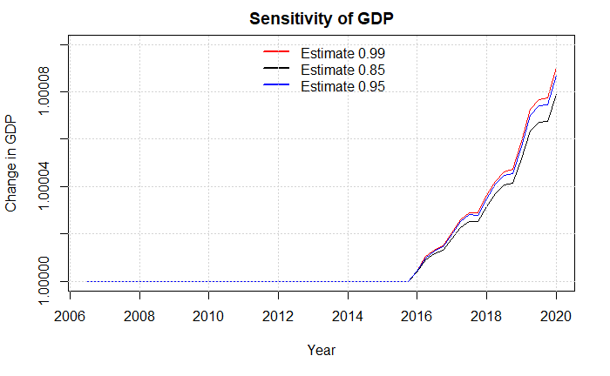

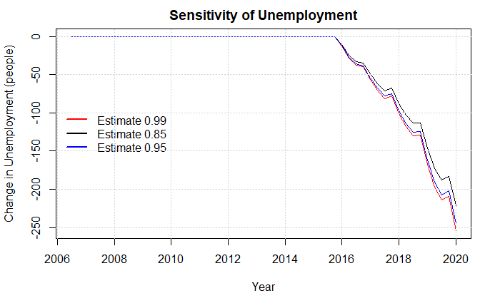

### Wage channel

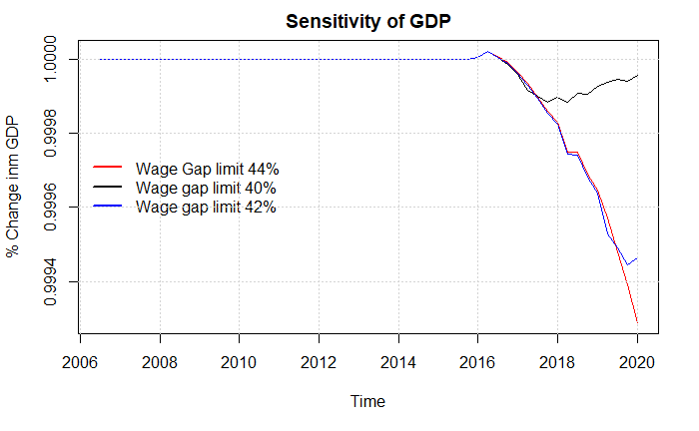

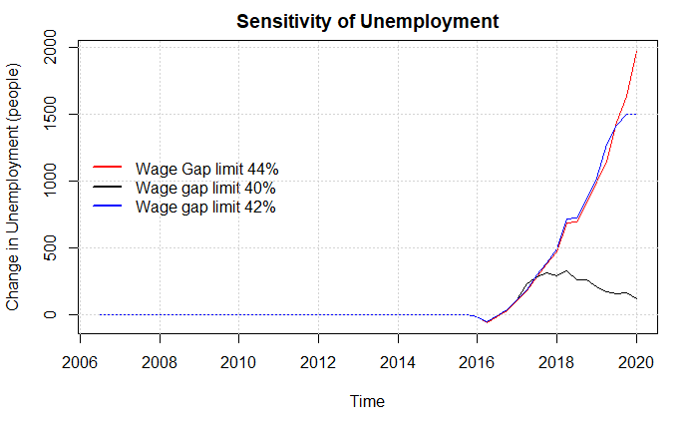

### Productivity channel

